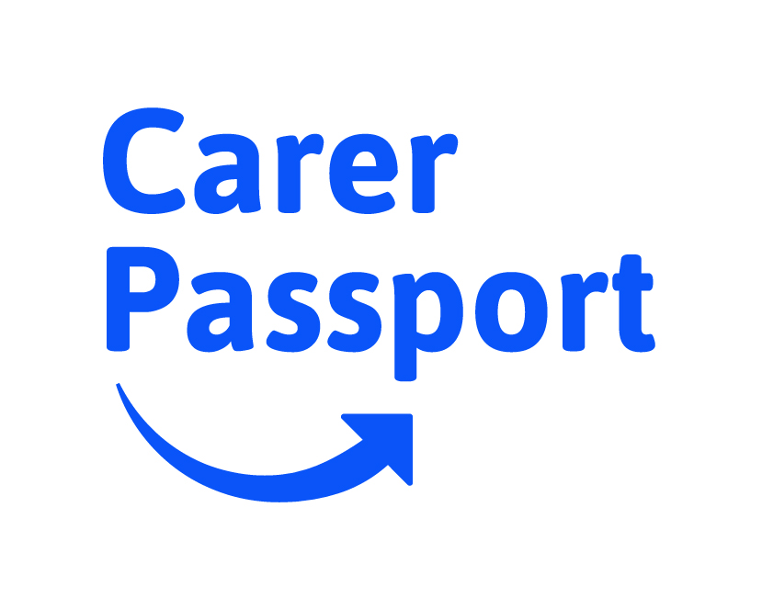

Dear colleague,
I’m delighted to tell you that [NAME] is now operating a Carer Passport scheme, as part of our approach to supporting staff who look after family or friends who have a disability, illness or who need support in later life.
Around 1 in 9 people in any given workforce will be juggling work with caring roles – and this is likely to increase over time. Yet caring is not an easy issue to talk about at work, either with your colleagues or with your line manager or HR team.
One of the reasons for operating a Carer Passport scheme is to help make these conversations more normal and more open.
That’s essentially what a Carer Passport is – it’s recognition that combining work with caring can be challenging, and that as an employer we want to make it OK to talk about the support and flexibility that could enable you to do your best in both vital roles.
It doesn’t mean that it will always be possible to accommodate this flexibility, but it does mean that we are serious as a business about trying to find solutions that work for both parties. And that you will never be penalised for asking.
What’s more, a Carer Passport means that whatever flexibility and workplace support is put in place will remain even if your role or manager changes, without you having to explain your circumstances over and again.
My senior colleagues, trustees and I are in agreement that doing what we can to support carers in our workforce is as good for our business as it is for the carers themselves. So we will be supporting the take-up of Carer Passports across the organisation and ensuring that we apply this scheme with consistency and fairness.
Please talk to the HR team or to your line manager for more details about the scheme.
Yours,

[Name]
[Title]

